**The Branding Journal**

[**https://www.thebrandingjournal.com/2015/05/what-to-learn-from-tropicanas-packaging-redesign-failure/**](https://www.thebrandingjournal.com/2015/05/what-to-learn-from-tropicanas-packaging-redesign-failure/)

**What to Learn From Tropicana’s Packaging Redesign Failure?**

**Author:**[**Marion**](https://www.thebrandingjournal.com/about/)[**May 1, 2015**](https://www.thebrandingjournal.com/2015/05/what-to-learn-from-tropicanas-packaging-redesign-failure/)

***Tropicana’s 2009 packaging redesign failure is in my eyes one of the most interesting case studies about branding through packaging design.***

At The Branding Journal we like to feature branding success stories, however sometimes analyzing branding failures is even more interesting, as it allows us to learn from past mistakes.

**1) Introduction:**

Tropicana is a very famous brand that sells fruit juice worldwide. On January 9th 2009, the PepsiCo-owned brand decided to replace the existing packaging design for its best-selling orange juice with new packaging for the North American market.

However, this new packaging design was rejected and criticized by the majority of Tropicana’s consumers. The launch of the new packaging was indeed such a failure that Tropicana had to drop it to come back to the original version of the packaging.

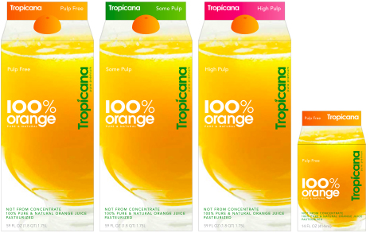

**2) Recap of the facts:**

First of all let’s summarize the facts to better understand the reasons for this packaging failure.

1. Tropicana invested 35 million dollars in an advertising campaign that promoted the new packaging for the fruit juice brand. Both the packaging design and the advertising campaign were created by the same agency; Arnell.
2. On January 8th 2009, Tropicana launched the new packaging for its best-selling product in North America – Tropicana Pure Premium, with sales revenues reaching more than 700 million dollars per year. A few days later, consumers started criticizing the new design, especially on social networks. Two months later, sales dropped by 20%, and this spectacular decrease in sales represented a lost of 30 million dollars for Tropicana.
3. Meanwhile, Tropicana’s competitors took advantage of the “Tropicana crisis” and gained the sales lost by the fruit juice brands.
4. On February 23rd 2009, Tropicana announced that it would return to its original packaging design, and within a few months, the old packaging was back for good on all supermarket shelve
5. In total, this initiative cost Tropicana more than 50 million dollars.

**3) Differences between the original packaging and the new one:**

[[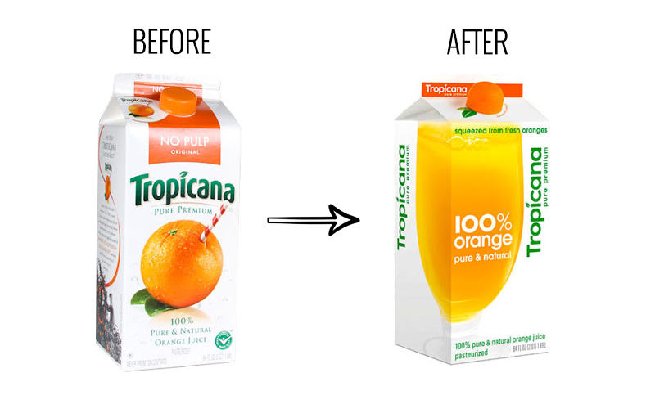](https://www.thebrandingjournal.com/wp-content/uploads/2015/05/Tropicana_Packaging_before_after.jpg)](https://www.thebrandingjournal.com/wp-content/uploads/2015/05/Tropicana_Packaging_before_after.jpg)

[To understand this strategy failure, it is important to analyze what did Tropicana change in its packaging design.](https://www.thebrandingjournal.com/wp-content/uploads/2015/05/Tropicana_Packaging_before_after.jpg)

*[“We thought it would be important to take this brand and bring it or evolve it into a more current or modern state.” stated Peter Arnell, director of the creative agency Arnell in his speech explaining the strategy chosen for the Tropicana product.](https://www.thebrandingjournal.com/wp-content/uploads/2015/05/Tropicana_Packaging_before_after.jpg)*

**[The images:](https://www.thebrandingjournal.com/wp-content/uploads/2015/05/Tropicana_Packaging_before_after.jpg)**

[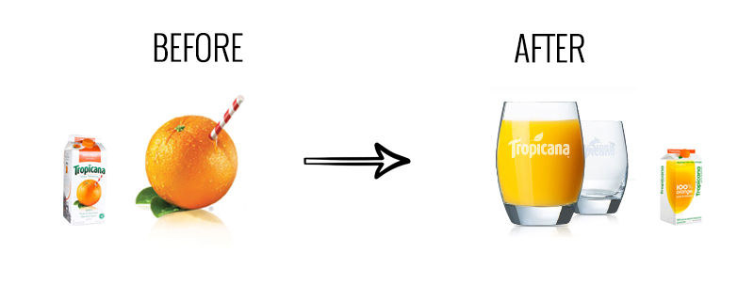](https://www.thebrandingjournal.com/wp-content/uploads/2015/05/Tropicana_Packaging_images_before_after.jpg)

Perhaps one of the most important changes is the fact that a big transparent glass full of orange juice replaced the orange and its straw.

*“Historically, we always show the outside of the orange. What was fascinating was that we had never shown the product called the juice.”*

**The lid:**

[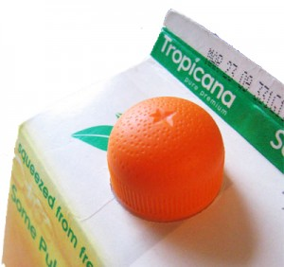](https://www.thebrandingjournal.com/wp-content/uploads/2015/05/tropicana_lid_packaging1.jpg)

[The agency decided then to take the orange and move it to the lid of the bottle. The idea is creative and interesting, as we can see that the cap really has the shape and texture of half an orange that you can squeeze to obtain a fresh orange juice. This message goes along with the new advertising campaign launched by the same time, and both the packaging and the ad include the statement “Squeeze, it’s a natural”.](https://www.thebrandingjournal.com/wp-content/uploads/2015/05/tropicana_lid_packaging1.jpg)

*[“We wanted to take the orange and put it somewhere. We engineered this interesting little squeeze cap here … so that the notion of squeezing the orange was implied ergonomically.”](https://www.thebrandingjournal.com/wp-content/uploads/2015/05/tropicana_lid_packaging1.jpg)*

**[The logo:](https://www.thebrandingjournal.com/wp-content/uploads/2015/05/tropicana_lid_packaging1.jpg)**

[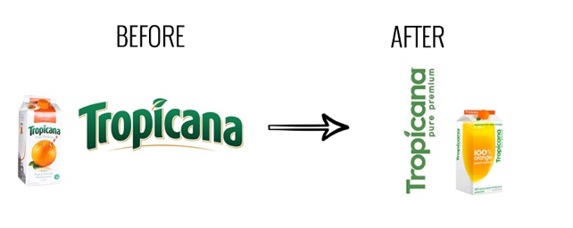](https://www.thebrandingjournal.com/wp-content/uploads/2015/05/Tropicana_logo_before_after.jpg)

Another important difference between the two packs is the new logo design.

The original one was horizontal followed by the product name “Pure Premium”, while the new logo is vertical with a simpler and more modern font. The logo size was also reduced to highlight the message: “100% Orange Pure and Natural”

**4) The advertising campaign that was released with the new packaging design**

Tropicana released a new advertising campaign along with its packaging strategy. The main message communicated in this campaign was “Squeeze, it’s a natural”.

*“The whole idea of ‘squeeze,’ ” Mr. Campbell said, is to play up “the functional benefit” of orange juice in providing fruit for people’s daily diets “and the emotional connection people have with Tropicana.”*

[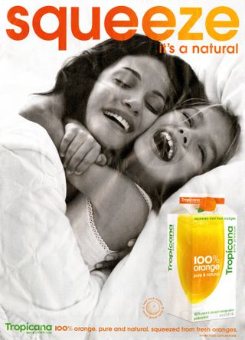](https://www.thebrandingjournal.com/wp-content/uploads/2015/05/Tropicana_squeeze_it_4.jpg)

[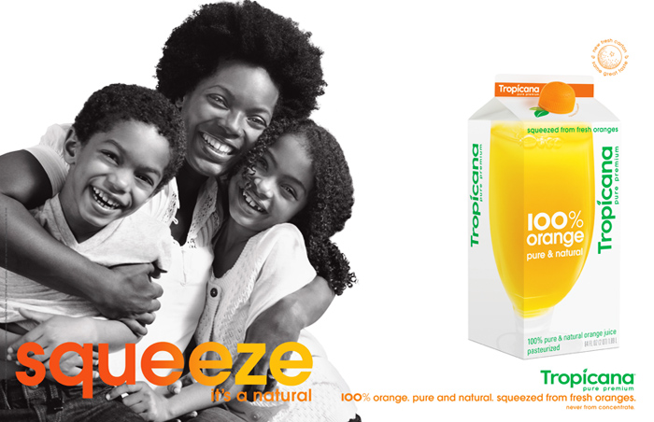](https://www.thebrandingjournal.com/wp-content/uploads/2015/05/Tropicana_squeeze_it_3.jpg)

[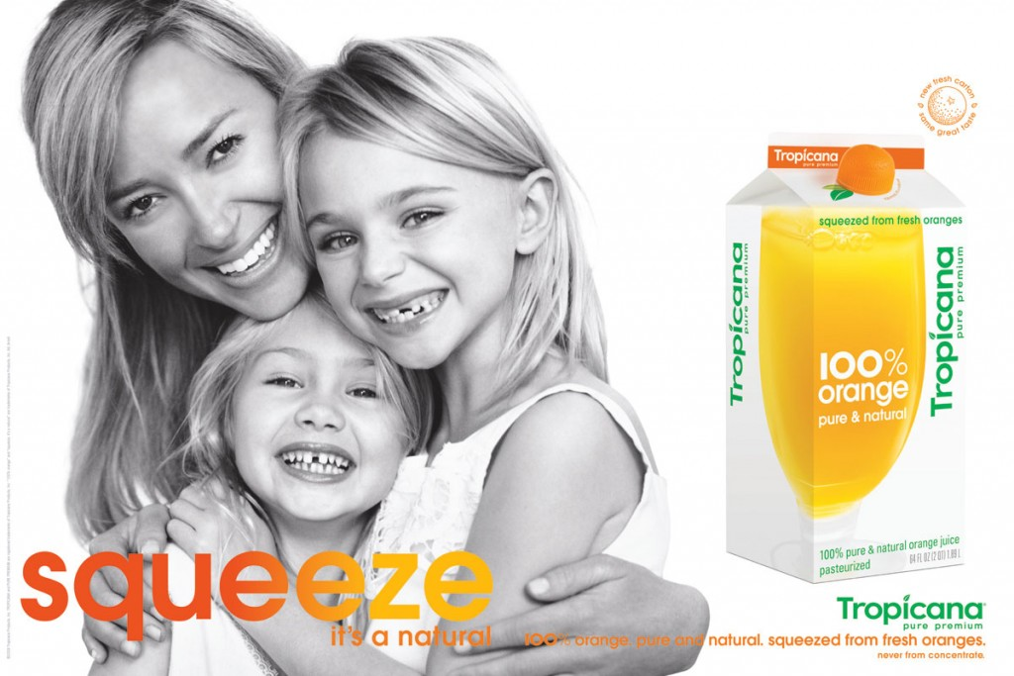](https://www.thebrandingjournal.com/wp-content/uploads/2015/05/Tropicana_squeeze_it_2.jpg)

[](https://www.thebrandingjournal.com/wp-content/uploads/2015/05/Tropicana_squeeze_it.gif)

**[5) Understanding the consumers’ reactions: what went wrong?](https://www.thebrandingjournal.com/wp-content/uploads/2015/05/Tropicana_squeeze_it.gif)**

**[Emotional bond with the brand](https://www.thebrandingjournal.com/wp-content/uploads/2015/05/Tropicana_squeeze_it.gif)**

*[“We underestimated the deep emotional bond they had with the original packaging” […]“What we didn’t get was the passion this very loyal small group of consumers have. That wasn’t something that came out in the research. […] Those consumers are very important to us, so we responded.” explained Mr. Campbell, president at Tropicana North America in Chicago.](https://www.thebrandingjournal.com/wp-content/uploads/2015/05/Tropicana_squeeze_it.gif)*

**[The role of packaging in purchasing decisions processes](https://www.thebrandingjournal.com/wp-content/uploads/2015/05/Tropicana_squeeze_it.gif)**

[Perhaps the problem goes beyond this emotional bond consumers had with the old packaging.](https://www.thebrandingjournal.com/wp-content/uploads/2015/05/Tropicana_squeeze_it.gif)

[It is very important to consider the role of packaging design in branding, and its link with merchandising. Young and Ciummo stated in their article that packaging redesigns often come with a small decrease in sales, but this tends to be temporary and has never been as severe as the 20% decrease experienced by Tropicana.](https://www.thebrandingjournal.com/wp-content/uploads/2015/05/Tropicana_squeeze_it.gif)

[In this case, many consumers didn’t recognize the product on supermarket shelves. Some loyal consumers saw the “100% Orange Juice” and asked themselves if the product was still the same as the Tropical Pure Premium they always trusted. Then appeared a series of confusions in consumers’ minds who lost their main reference elements to recognize the product. These include:](https://www.thebrandingjournal.com/wp-content/uploads/2015/05/Tropicana_squeeze_it.gif)

The orange with the straw

* The original logo
* The focus on “100% Orange” instead of “Pure Premium”.

**The look and feel of the new design:**

To finish, and because the packaging had a more simple design than the original one, most consumers described it as “ugly”, and explained it seemed to be from a low-range supermarket brand. Consumers were confused by this new look that made the brand seem to be cheap, as Tropicana had always been perceived as a premium brand.

**6) What to learn from this case study:**

Branding is a complex subject and it is often difficult to predict the market’s reaction to a strategy change.

However, I believe that, both from an individual and company-standpoint, we can learn several lessons from Tropicana’s strategic mistake:

1. **Consumers feel an emotional bond with the appearance of the product and brand they love.**

Consumers have an emotional connection with brands they purchase and can feel betrayed and disappointed if they suddenly can no longer identify with new brand elements of the packaging design. It is important to always consider this before making changes to packaging designs.

1. **Branding elements on a packaging cannot all be changed at once**  
   Tropicana, while trying to modernize the brand, didn’t respect one of the most important branding rules any company should consider: the product identification and recognition by the consumer.  
   Tropicana changed too many brand elements that confused the customers on the moment they wanted to purchase orange juice:
   * new logo
   * new typography
   * new slogan
   * new image
   * new lid

If you want to redesign your product’s packaging, make sure you do not change everything at once. The changes need to be done progressively to ensure the consumer will still recognize the brand.

Of course, this only applies for successful brands such as Tropicana. If your brand and product are not doing well, a total rebrand can be a good solution to save the product on the market. In fact, we’ve seen many cases (Herbal Essences comes to mind) in which significant packaging changes have driven sales.

1. **Packaging is the silent salesman**

Packaging is the last communication element brands have with consumers on the purchasing decision process. Its design and content are essential to the brand because it will influence the consumer’s decision at the last minute. Tropicana’s consumers didn’t recognize or like the new product design, and therefore decided not to purchase it.

1. **Advertising and Packaging Design have different communication rules**

Advertising and packaging design are very different communication tools.

* Through advertising, companies have more time and support to communicate emotions and new values. The mission of advertising is to inform and communicate sensations that will last in the long-term. It is a more flexible communication support over time.
* Through packaging design, companies need to communicate in a more direct, clear and identifiable manner, as the consumer is about to make its final purchase decision.

Of course, packaging and advertising strategies should always be in line, as with any marketing activity in general. However, there are some communication codes to each domain that need to be respected. In the case of Tropicana, the packaging codes weren’t, and this caused the failure of the new design.

**7) Conclusion:**

The Tropicana redesign illustrated the considerable power of packaging. While this was a distinctively negative example, it’s important to keep in mind that this same power does often work in a positive direction.

The takeaway for marketers and brand strategists should be an even greater respect for packaging and a deeper commitment to leveraging this brand asset with a methodical procedure. This will ensure consumers accept the change in a positive manner!

***References:***  
*–****Online:***[*CBS News*](http://www.cbsnews.com/news/arnells-explanation-of-failed-tropicana-design-resembles-his-nonsensical-pepsi-document/)*,*[*NY Times*](http://www.nytimes.com/2009/01/08/business/media/08adco.html?_r=0)*,*[*NY Times (2)*](http://www.nytimes.com/2009/02/23/business/media/23adcol.html?pagewanted=all)  
*–****Marketing Journal:****Young Scott y Ciummo Vicenzo. “Managing risk in a package redesign: what can we learn from Tropicana? “. Brand Packaging (August 2009)*